Question 1
#include<stdio.h>
#include<stdlib.h>
int main()
{
int size,n,*arr;
printf("enter the size of the array:");
scanf("%d",&size);
arr=(int *) malloc (size*sizeof(int));
if(arr==NULL)
{
printf("error");
return 0;
}
printf("enter the value of arrray:\n");
for (int a=0;a<=size;a++)
{
scanf("%d",&n);
arr[a]=n;

}
int length=sizeof(arr);
printf("printed the element of repeation is:\n");

for(int i=0;i<length;i++)
{
for(int j=i+1;j<length;j++)
{
if(arr[i]==arr[j])
{
printf("%d\n",arr[j]);
}
}
}
free(arr);
}

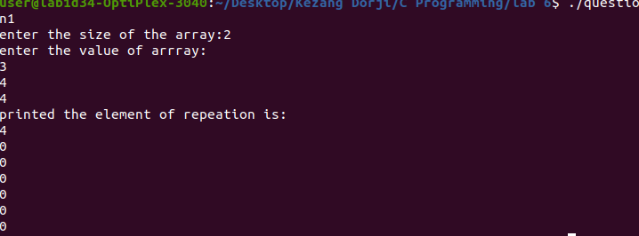
Output:

Question 2
#include<stdio.h>
#include<stdlib.h>

int main(int argc, char* argv[])
{
int rows = 0;
int cols = 0;
int height = 0;
int ***array;
int r, c, h;

printf ("Enter 3D Array rows : ");
scanf ("%d", &rows);

printf ("Enter 3D Array columns : ");
scanf ("%d", &cols);

printf ("Enter 3D Array Layer : ");
scanf ("%d", &height);

array = (int ***) calloc (height,sizeof(int ***));
for (h = 0; h < height; h++)
{
array[h] = (int **) calloc(rows,sizeof(int*));
for (r = 0; r < rows; r++)
{
array[h][r] = (int *) calloc(cols,sizeof(int));
}
}

for (h = 0; h < height; h++)
{
for (r = 0; r < rows; r++)
{
for (c = 0; c < cols; c++)
{
printf ("Enter Array Element of [%d][%d][%d] : ", h, r, c);
scanf ("%d", &array[h][r][c]);
}
}
}

printf("Displaying 3D Array:\n");

for (h = 0; h < height; h++)
{
printf("Layer %d\n", h);
for (r = 0; r < rows; r++)
{
for (c = 0; c < cols; c++)
{
printf("%.2d ", array[h][r][c]);
}
printf("\n");
}
printf("\n");
}

return 0;
}

Output
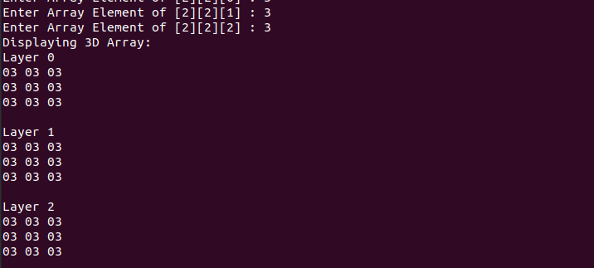

Question 3
#include<stdio.h>
#include<math.h>
int product(int *i,int *j)
{
int mul=*i**j;
return mul;
}
int mean(int *i,int *j)
{
int mid=(*i+*j)/2;
}
int deviation(int *i,int *j)
{
int sum=*i+*j;
int mean=sum/2;
float SD=pow(sum-mean,2);
return sqrt(SD/2);
}
int main()
{
int a,b,mul;
printf("give the value of a:");
scanf("%d",&a);
printf("give the value of b:");
scanf("%d",&b);
printf("the product is:%d\n",product(&a,&b));
printf("the mean is:%d\n",mean(&a,&b));
printf("the standard deviation is:%d",deviation(&a,&b));
return 0;
}

Question 4
#include<stdio.h>
int main()

{
int arr[] = {1, 2, 3, 4, 5};
int length = sizeof(arr)/sizeof(arr[0]);
int n = 2;
printf("Before: \n");
for (int i = 0; i < length; i++)
{
printf("%d ", arr[i]);
}
for(int i = 0; i < n; i++)
{
int j, first;
first = arr[0];

for(j = 0; j < length-1; j++)
{
arr[j] = arr[j+1];
}
arr[j] = first;
}

printf("\n");
printf("After left rotation: \n");
for(int i = 0; i < length; i++)
{
printf("%d ", arr[i]);
}
printf("\n");
return 0;
}

Output
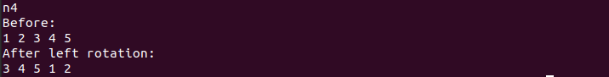

Question 5
#include <stdlib.h>
#include<stdio.h>
int main()
{

// This pointer will hold the base address of the block created
int* ptr;
int n, i;

// Get the number of elements for the array
printf("Enter number of elements: ");
scanf("%d", &n);

// Dynamically allocate memory using malloc()
ptr = (int*)malloc(n * sizeof(int));

// Check if the memory has been successfully
// allocated by malloc or not
if (ptr == NULL) {
printf("Memory not allocated.\n");
exit(0);
}
else {

// Memory has been successfully allocated
printf("Memory successfully allocated\n");

// Get the elements of the array
printf("Enter the elements: \n");
int a;
for (i = 0; i < n; ++i) {
scanf("%d", &a);
ptr[i] = a;
}

// Print the elements of the array
printf("The elements of the array are: ");
for (i = 0; i < n; ++i) {
printf("%d, ", ptr[i]);
}
printf("\n");
}

return 0;
}

Output
#include <stdlib.h>
#include<stdio.h>
int main()
{

// This pointer will hold the base address of the block created
int* ptr;
int n, i;

// Get the number of elements for the array
printf("Enter number of elements: ");
scanf("%d", &n);

// Dynamically allocate memory using malloc()
ptr = (int*)malloc(n * sizeof(int));

// Check if the memory has been successfully
// allocated by malloc or not
if (ptr == NULL) {
printf("Memory not allocated.\n");
exit(0);
}
else {

// Memory has been successfully allocated
printf("Memory successfully allocated\n");

// Get the elements of the array
printf("Enter the elements: \n");
int a;
for (i = 0; i < n; ++i) {
scanf("%d", &a);
ptr[i] = a;
}

// Print the elements of the array
printf("The elements of the array are: ");
for (i = 0; i < n; ++i) {
printf("%d, ", ptr[i]);
}
printf("\n");
}

return 0;
}

Output

